How to credit under member’s name.
- Go to the following website. https://givebutter.com/MaddiesMiraclesWalkathon (You do not need to register with Givebutter to donate.)
- Click the purple “Donate & Tickets” button.
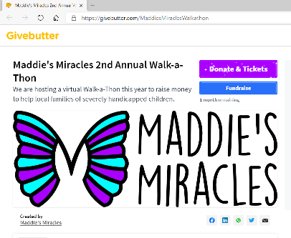
- Select “No thanks, I’d just like to donate.”
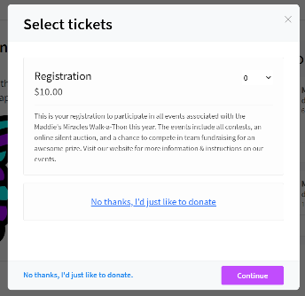
- Choose option for amount, or you can type in a custom amount. Then select “No member” or the member’s name you would like to add your donation under.
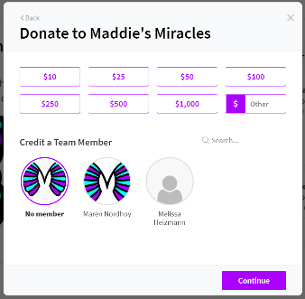
- Click purple “Continue” button at bottom right side of page.
- You may then add a public message, photo, GIF or drawing to your donation. (optional)
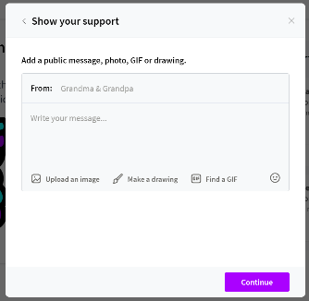
- Click purple “Continue” button at bottom right side of page.
- “Final Details” will show the break down of your donation and fees. It will also give you the option to “Hide your name and amount from public view.” Select payment option (Card, Venmo, or PayPal).
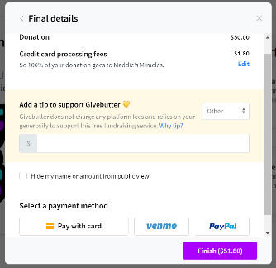
- Click purple “Finish (amount of donation)” button at bottom right side of page to finalize your donation.
